

Statistical Techniques

Work Instruction

Purpose

The purpose of this work instruction is to describe methodologies and provide guidance on the selection of statistical techniques for risk based determination of the sample size and data analysis for design verification and validation and process validation activities.

Scope

This work instruction can apply to any situation which requires the selection of a sample size and data analysis for the purposes of design verification and validation testing or process validation testing. In situations where a recognized standard or guideline provides alternate methodology for sample size, the standard or guideline should generally prevail.

This work instruction is not applicable to lot based sampling and lot release that is performed during normal manufacturing activities.

The confidence and reliability levels specified in this procedure are intended to provide minimum levels for design verification and validation testing or process validation testing. Higher confidence and reliability levels may be used based on the type of product or process being tested, but lower levels may not be used without justification contained within the protocol.

This work instruction applies to subcontractors performing design verification and validation testing or process validation testing on behalf of SILQ.

Documents

Reference Documents

QM.SLQ009 Design Verification and Validation

QM.SLQ012 Risk Management

QM.SLQ013 Risk Analysis

ISO 13485 International Standards Organization – Medical Devices – Quality Management Systems (section 8.1 –Measurement, Analysis and Improvement: General)

21 CFR 820 Quality System Regulation (820.250 – Statistical Techniques)

Introduction to Statistical Quality Control – Fifth Edition: Douglas C. Montgomery

Probability and Statistics for Engineers and Scientists – Third Edition: Walpole & Myers

The New Weibull Handbook – Fourth Edition: Dr. Robert B. Abernethy

Statistical Intervals: A Guide for Practitioners – First Edition: Hahn & Meeker

NIST/SEMATECH e-Handbook of Statistical Methods, http://www.itl.nist.gov/div898/handbook

Associated Forms/Templates

N/A

Definitions

Abbreviations / Acronyms

QA: Quality Assurance

QMS: Quality Management System

SOP: Standard Operating Procedure

V&V: Verification and Validation

WI: Work Instruction

General Definitions

Attribute Data: data limited to just two values such as defective or non-defective; high or low; good or bad. Also called pass/fail or go/no go data.

Confidence Interval: An estimated range of values that, with a degree of certainty, is likely to contain the population parameter and which the estimated range is calculated from a set of sample data.

Confidence Level: The probability value (1-α) associated with a confidence interval typically expressed as a percentage.

Design Of Experiments (DOE): A structured and systematic method for determining the relationship between factors and input variables that affect a process and the resulting effect on the pre-determined output of that process.

Normal Distribution - A continuous random variable x is said to have a normal distribution if the density curve of x is a normal “bell-shaped” curve. The mean value m determines where the curve is centered on the measurement axis, and the standard deviation s determines the extent to which the curve spreads out about 99.74% of the process values are within 3 standard deviations of the mean.

Operational Qualification (OQ): A documented test demonstrating the process and equipment being validated is operating as designed and per specification over the range of allowable process parameters.

Performance Qualification (PQ): A documented test of the consistent performance of the process. The PQ should include verification of the stability of the process (Process Performance Qualification), and an evaluation of the product produced by the process to show conformance to specification (Product Performance Qualification).

Population: The total number distribution of items or measurements that are of concern and from which a set of samples is taken. The population is distributed with a mean (μ) and a standard deviation (σ).

Reliability: the consistency of a measure (i.e., the closeness of the initial estimated value(s) to the subsequent estimated values).

Sample: A representative subset of a population. A sample is distributed with a mean (¯x ) and a standard deviation (s) that are estimates of the population mean (μ) and standard deviation (σ).

Type Test: A test which is confirming the presences or absence of an inherent property of the material which is unlikely to vary based upon process parameters. These would typically include such things as biocompatibility and chemical compatibility.

Validation: Confirmation, by examination and provision of objective evidence, that the particular requirements for a specific intended use can be consistently fulfilled.

- Process validation: The act of establishing, by objective evidence, that a process consistently produces a result or product meeting its predetermined specifications.

- Design validation: The act of establishing, by objective evidence, that device specifications conform to user needs and intended uses.

Variable Data: Measurement data, typically determined using some type of continuous scale, e.g. length, elongation, shear strength, etc.

Verification: Confirmation, by examination and provision of objective evidence, that specified requirements have been fulfilled.

Worst-case: A set of conditions encompassing combinations of upper and/or lower specification limits and circumstances, including those within standard operating procedures, which present the highest probability of causing the process or product to fail to meet product or process specifications and/or quality parameters when compared to ideal conditions. Worst-case conditions do not necessarily induce product or process failure.

Responsibilities

It is the responsibility of the Quality Assurance to ensure proper statistical techniques are utilized for analyzing design verification and validation data and process validation data.

It is the responsibility of all SILQ personnel involved in approving and performing verification and validation to follow this procedure.

General Requirements: Statistical Techniques

The use of statistical methods applies to a wide range of circumstances, including data collection, analysis, and application to gain a better understanding of requirements and expectation. Statistical methods may be applied in product, service, process design and control, nonconformity avoidance, problem analysis, risk determination, finding root causes, establishing product and process limits, forecasting, verification, validation, and assessment of quality characteristics. The focus and intent of this procedure is to provide guidance on statistical techniques and sample size determination specific to design verification and validation testing and process validation testing including process capability studies.

Design of Experiments (DOE) is used to determine which candidate variables have significant influence on process and product performance, and for quantifying the effects. DOE may include, but is not limited to the following types of studies:

Investigating the effect of varying one factor (One-factor experiment).

Investigating the effect of varying two or more factors (Designs for two or more factors).

Experimenting under process conditions to determine optimum settings of variables.

Determining the optimum set of values of a group of variables that affect a response variable (Surface Response methodology).

Inspection/test requirements for process validations are to, at a minimum, meet released specifications documented in the product DMR and are to be stated in approved verification / validation protocols.

The Performance Level and Confidence Level requirements of a process validation OQ and PQ should meet or exceed the criteria used in the receiving inspection and in-process and final acceptance sample plans.

Verification of performance to specification is to be accomplished, wherever possible, to worst-case conditions that are to be simulated (minimum voltage, maximum flow, etc.) for testing. Each test should be repeated to gather a selection of data points under the same test conditions to provide an indication of the repeatability. When worst-case cannot be simulated for all parameters, samples should be selected using Design of Experiment practices (e.g. include appropriate samples from groups of each major source of variation of remaining parameters).

Process capability analysis is used to evaluate a process to see if it is capable of producing products within specifications. The analysis determines the closeness of the observed results to the nominal or target value, and ensures that the results are within the specified upper and lower limits.

Procedure: Sample Size Determination

All samples selected are to be done so in such a manner as to be representative of the larger population from which the samples are taken. An individual lot manufactured for providing representative samples of a product is to be produced in a single continuous run.

Sample size required for any test / verification will depend on multiple factors including, but not limited to, the process or action the test is designed to validate, test and process variations and their source, and the confidence interval required.

In general, sample size determination for verification and validation testing should be determined using a risk based sampling approach. As such, the confidence and reliability levels are chosen based on the results of related risk analysis (i.e., Hazard Analysis, Design FMEA, and Process FMEA, etc.), refer to QM.SLQ013, Risk Analysis SOP. See Sections 7.5.3 and 7.6.3 below for specified minimum confidence and reliability levels.

Cases where sample size is not based on associated confidence and reliability levels or are limited, include the following:

Software Testing: Due to the high reproducibility and repeatability of software, the sample size tested in stand-alone application software tests may be one. In those tests where software controls hardware to produce a physical effect, sample sizes are to be determined as described in this procedure.

Labeling/Instruction Content Testing: During validation of labeling content, the purpose is to validate the appearance and content of the label, or to validate the usability of the instructions provided. In either case, there will be no variation of the physical label from sample to sample so a single sample is sufficient for validation.

External Regulatory or Governing Standards Testing: An applicable or governing standard may define the required sample size for the test. If so, use the required sample size defined in the standard.

Type Test: If the test is confirming the presences or absence of an inherent property of the material which is unlikely to vary based upon process parameters, then a sample size of one is considered acceptable to complete the test. These would typically include such things as biocompatibility, chemical compatibility and electromagnetic compatibility / interference.

Design Verification and Validation

For design verification and validation activities appropriate application of statistical techniques must be carefully considered. In many instances alternative approaches such as worst case testing may be used in lieu of testing a statistically significant sample.

It should be noted that while the FDA’s definition of process validation contains the term “consistently” which imparts the use of statistically based confidence and reliability levels, the corresponding definitions of design verification and validation contain no such reference. The FDA acknowledges the use of numerous methods in design verification and validation that do not require nor lend themselves to the statistical techniques defined in this procedure.

The confidence and reliability levels specified is this section for design verification and validation are lower than levels typical for process validation for the following reasons:

Verification activities occur at various levels within the design (component, sub-assembly, assembly, domain, system) and as such many attributes / characteristics are verified numerous times.

Process validation activities often repeat and verify consistency of the same attributes / characteristics verified during design verification and validation thereby providing additional confidence in the results of design verification and validation.

The typical pre-production nature of design verification and validation activities significantly limits the availability of representative samples for testing.

The intent of design verification and validation is to verify the basic designs conformance to specifications and requirements, not the ability of the design to consistently conform, which is the subject of process validation.

For design verification and validation activities where the application of statistically based sampling is appropriate, determine the risk category per the Risk Management SOP QM.SLQ012, and apply the following minimum reliability and confidence levels:

Risk Category: High Risk Level - A minimum Confidence Level of 95% and Reliability of 90% is suggested.

Risk Category: Medium Risk Level - A minimum Confidence Level of 90% and Reliability of 90% is suggested.

Risk Category: Low Risk Level - A minimum Confidence Level of 80% and Reliability of 80% is suggested.

Process Validation Activities

Confidence and reliability levels defined in this procedure are not applicable to Installation Qualification (IQ) activities performed as a part of process validation.

Operational qualification (OQ) activities performed as a part of process validation generally include evaluation of process performance at the limits of process variables / set-points. The data typically gathered during OQ activities is intentionally skewed to represent worst case conditions and is clearly not representative of the overall population. As result, the application of typical confidence and reliability levels to capture and predict process variability is of limited application and may cause redundancy with PQ activities.

For process and product performance qualification (PQ, PPQ) activities as a part of process validation, determine the risk category per the referenced risk management procedure and apply the following minimum reliability and confidence levels:

Risk Category: High Risk Level - A minimum Confidence Level of 95% and Reliability of 99% is suggested.

Risk Category: Medium Risk Level - A minimum Confidence Level of 90% and Reliability of 95% is suggested.

Risk Category: Low Risk Level - A minimum Confidence Level of 90% and Reliability of 90% is required.

Procedure: Statistical Methods for Variable Data

Most variables data sample size formulas assume a normally distributed population. Certain statistical approaches are more or less robust against the normality assumption; with tolerance limits the assumption of normality is critical. Other approaches, or non-parametric methods, make no assumptions that the underlying population is normal.

Normal distribution

The variable data analysis methods presented in this procedure assume the data is normally distributed. It is recommended that an appropriate normality test (e.g., Normal probability plot, Shapiro-Wilk test, Anderson-Darling test, etc.) is performed to assess the normality of variable data prior to use of the analysis methods.

If the data is not normal, the data may be transformed using the log of the values or other suitable transformation such as square root or reciprocal (1/Y) transformations.

NOTE: Transform the specifications as well and compare to the transformed data to make acceptance decisions.

If the data does not meet this criterion, there are calculations to assess whether the departure from normality is practically significant (i.e. is the proportion of the population in the relevant tails likely to be underestimated by the assumption of normality; for example for a one-sided tolerance interval is the data skewed with the longer tail away from the specification limit). The data may be treated as normal if it passes this test.

If a specific test requires data analysis using some other statistic than what is presented in this procedure (e.g. binomially distributed data), the appropriate statistic for a specific distribution may be used if a reference is given for the standard statistic or standard software application used. A distribution-free (nonparametric) tolerance interval may be used in any case. Because no specific population distribution is assumed, the resulting tolerance interval will be larger than the distribution-dependent tolerance interval, but potential risk associated with assuming a specific distribution is avoided. Tables of binomial and distribution-free tolerance factors are available in statistics references such as Hahn and Meeker.

Specifications with Upper and Lower Limits

Use of this data analysis technique assumes a Normal distribution.

When a specification is given with upper and lower limits (i.e. 100 +/- 10 ml/min), the desired outcome shows with some degree of confidence that some percent of the population will fall within the specification limits based on the sample mean and sample standard deviation. The figures below show populations that will meet and will not meet specification.
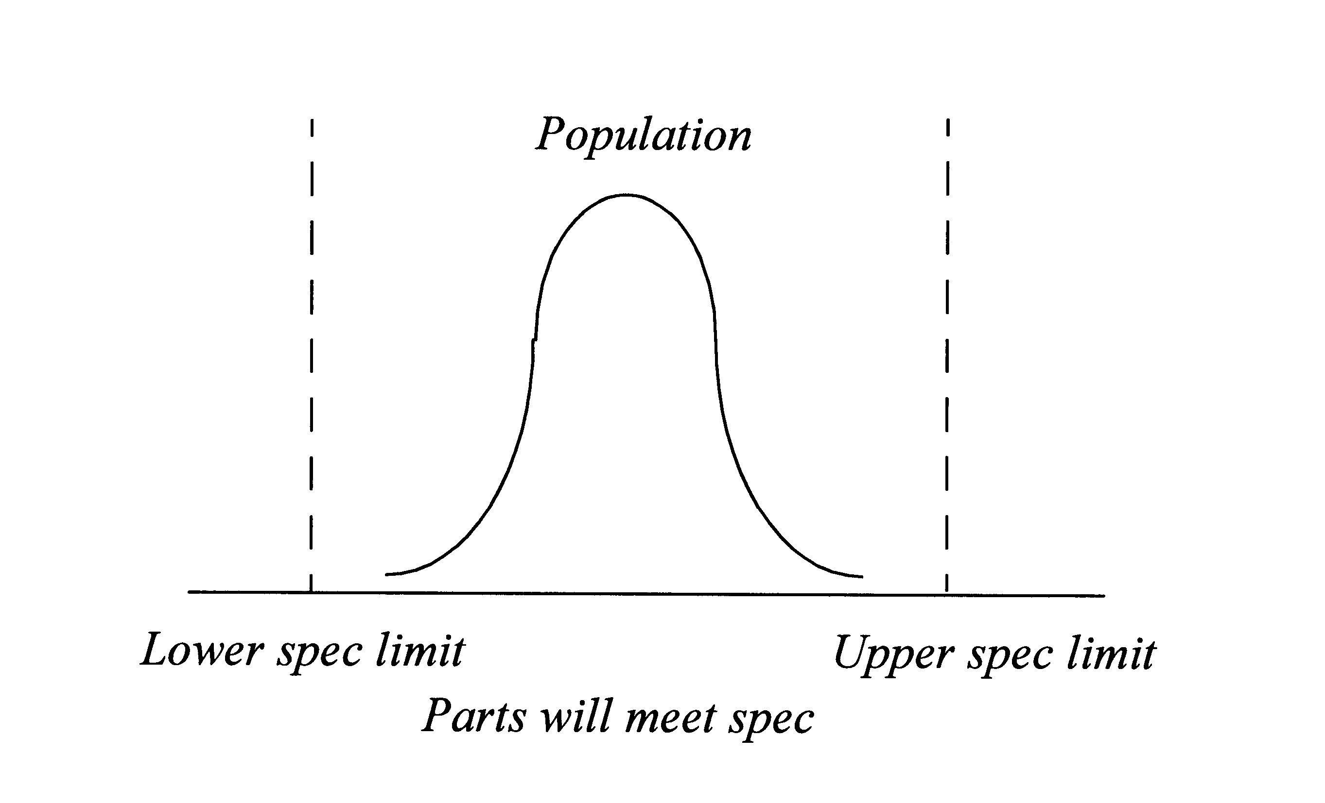
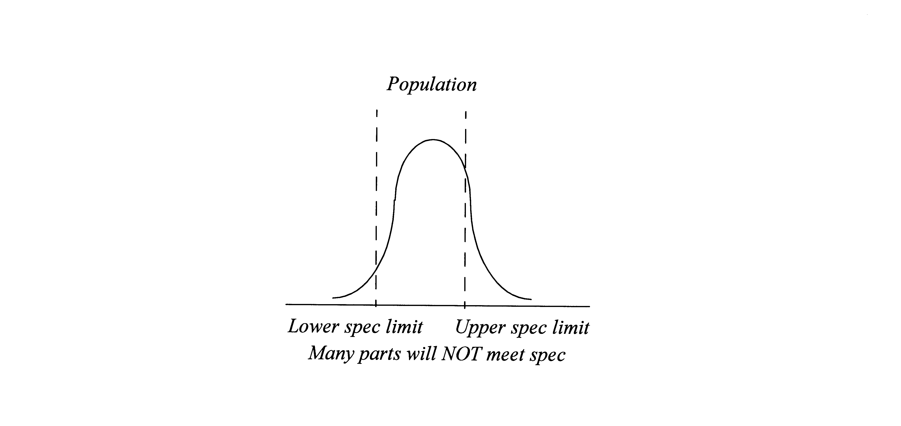

To translate the sample statistics into the population statistics, a tolerance interval calculation is used. This calculation takes into account the uncertainty involved in estimating the population mean and standard deviation based on the sample statistics and the sample size. The tolerance interval gives:

We can state with (1-α) confidence that γ% of the population will fall between:
¯x ± ks

where ¯x is the sample mean, s is the sample standard deviation, and k is the tolerance limit factor, defined by a lookup table shown below, depending on (1-α) confidence and γ% of the population desired.
Table 1: The tolerance limit factor, k, is given by the following table:
k, two-sided normal tolerance limit factor
Number of Samples  “n” | 80% confident,  80% of population | 90% confident,  90% of population | 90% confident,  95% of population | 90% confident,  99% of population | 95% confident,  99% of population
3 | 3.133 | 5.851 | 6.972 | 9.163 | 12.860
4 | 2.475 | 4.167 | 4.965 | 6.525 | 8.299
5 | 2.187 | 2.586 | 4.164 | 5.472 | 6.634
6 | 2.022 | 3.131 | 3.730 | 4.903 | 5.775
7 | 1.915 | 2.901 | 3.457 | 4.543 | 5.248
8 | 1.839 | 2.742 | 3.368 | 4.294 | 4.891
9 | 1.783 | 2.625 | 3.128 | 4.111 | 4.631
10 | 1.738 | 2.535 | 3.021 | 3.970 | 4.433
11 | 1.703 | 2.463 | 2.935 | 3.857 | 4.277
12 | 1.673 | 2.404 | 2.865 | 3.765 | 4.150
13 | 1.649 | 2.355 | 2.806 | 3.688 | 4.044
14 | 1.628 | 2.313 | 2.757 | 3.623 | 3.955
15 | 1.610 | 2.277 | 2.714 | 3.566 | 3.878
16 | 1.594 | 2.246 | 2.676 | 3.517 | 3.812
17 | 1.580 | 2.219 | 2.644 | 3.474 | 3.754
18 | 1.567 | 2.194 | 2.614 | 3.436 | 3.702
19 | 1.556 | 2.172 | 2.588 | 3.402 | 3.656
20 | 1.546 | 2.152 | 2.567 | 3.371 | 3.615
21 | 1.536 | 2.134 | 2.543 | 3.343 | 3.577
22 | 1.528 | 2.118 | 2.524 | 3.317 | 3.543
23 | 1.520 | 2.103 | 2.506 | 3.294 | 3.512
24 | 1.513 | 2.090 | 2.490 | 3.272 | 3.483
25 | 1.507 | 2.077 | 2.475 | 3.252 | 3.457
30 | 1.480 | 2.025 | 2.413 | 3.171 | 3.350
35 | 1.460 | 1.988 | 2.368 | 3.112 | 3.272
40 | 1.445 | 1.959 | 2.334 | 3.067 | 3.213

Once the k factor is determined from the appropriate criticality numbers, the expected range of the population is tested against the specification. Appropriate acceptance criteria for two-sided data are as follows:
¯x + ks < maximum specification
and
¯x - ks > minimum specification.

Single-sided Specifications

Use of this data analysis technique assumes a Normal distribution.

When a specification is given with only one limit (i.e. greater than 10%, less than or equal to 200 mmHg, etc.), the desired outcome shows with some degree of confidence that some percent of the population will fall within the specification limit based on the sample mean and sample standard deviation. The figures below show populations that will meet and will not meet specification.
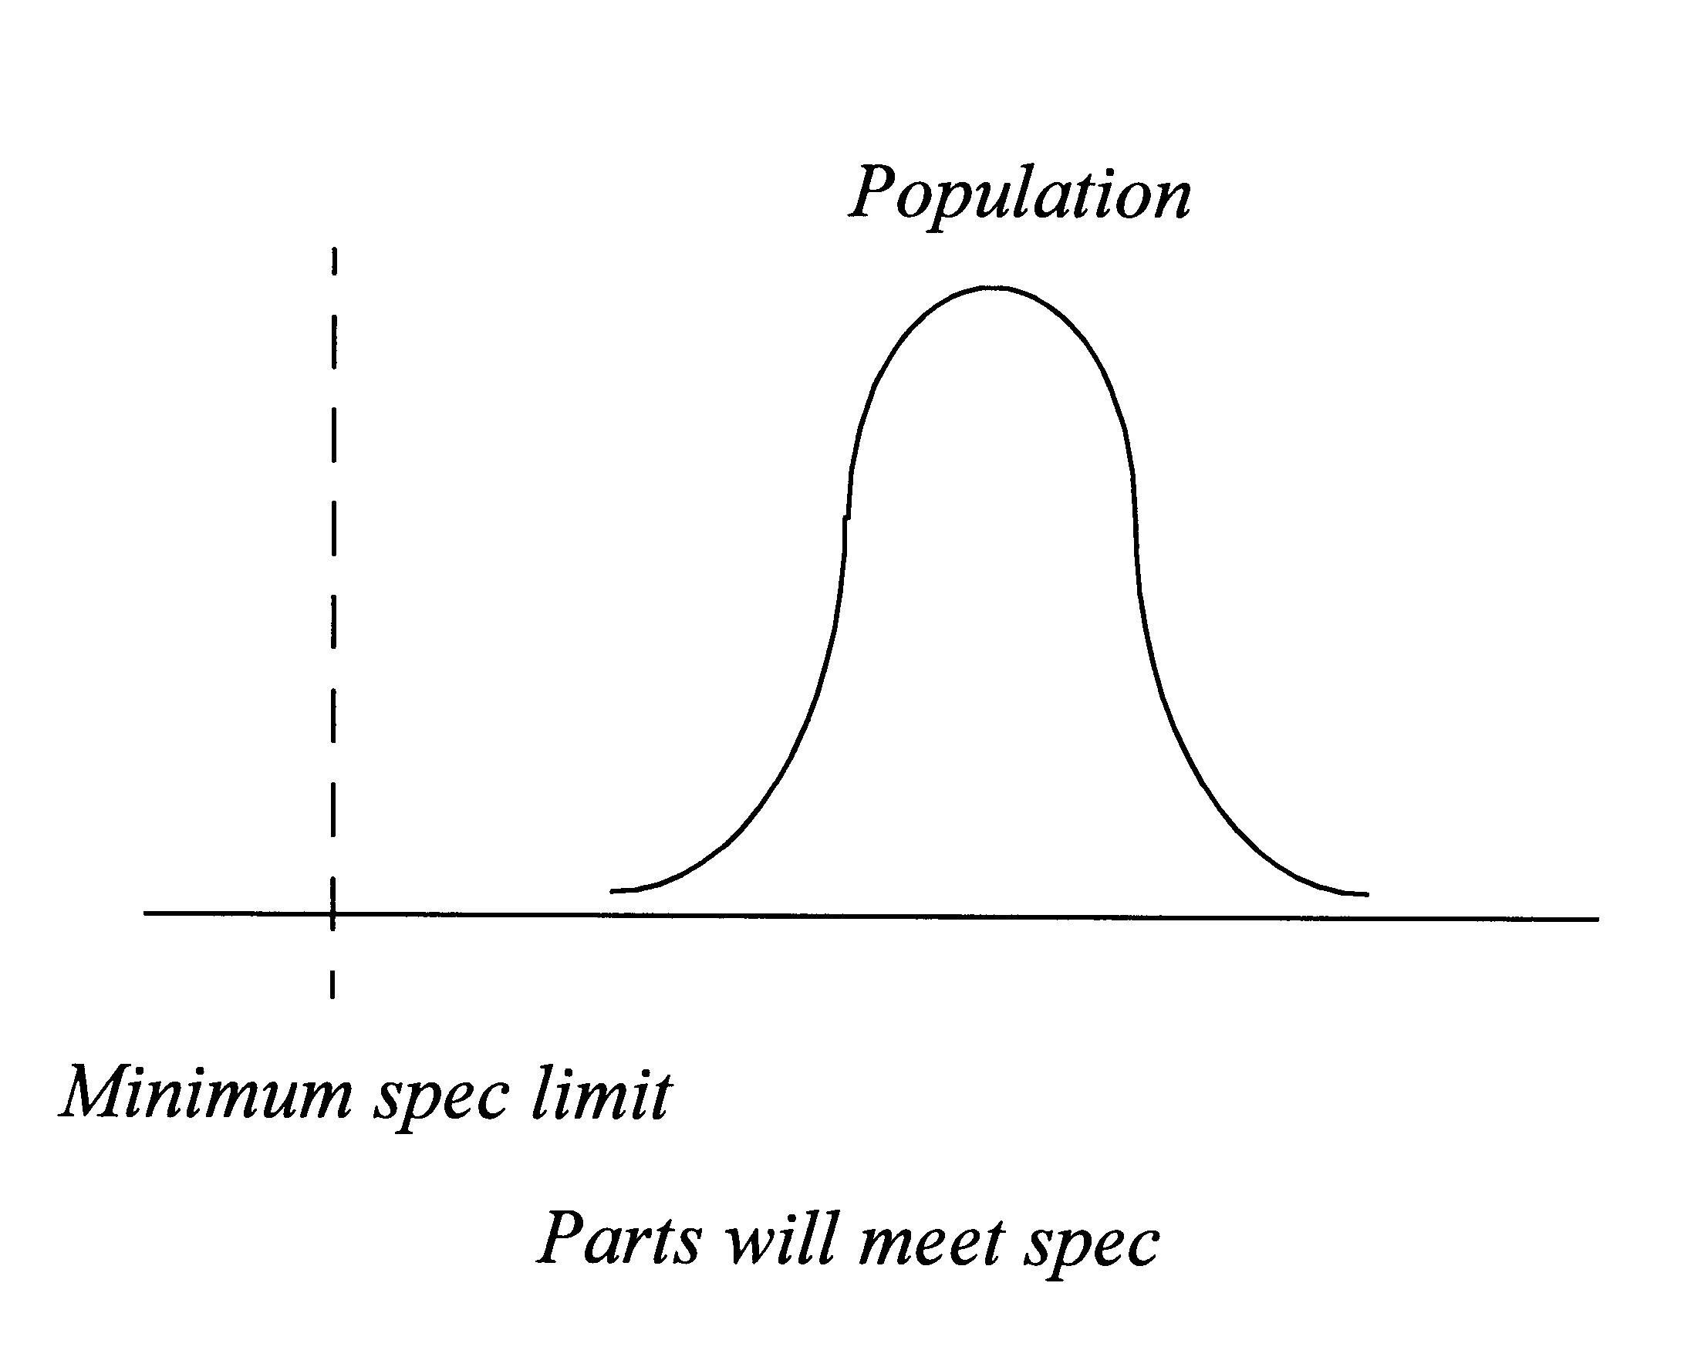
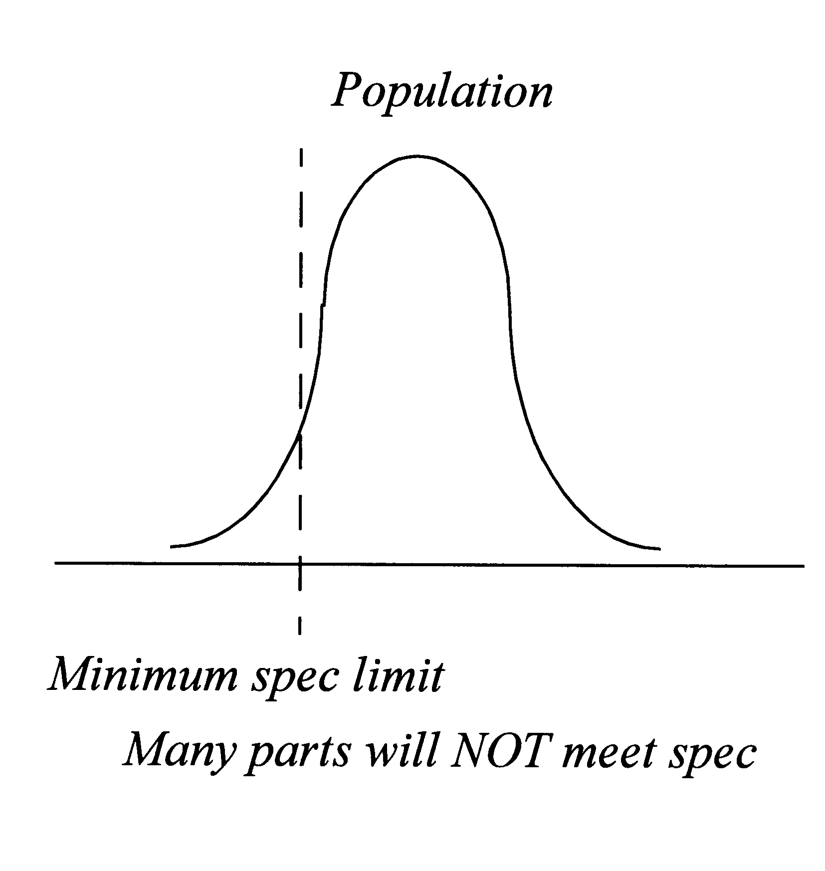

To translate the sample statistics (mean, standard deviation) into the population statistics, one portion of the same tolerance interval calculation is used (either plus or minus, depending on the specification). This calculation takes into account the uncertainty involved in estimating the population mean and standard deviation based on the sample statistics and the sample size. The tolerance interval gives:
We can state with (1-α) confidence that γ% of the population will be above/below:
¯x + ks upper population range
or
¯x - ks lower population range
where ¯x is the sample mean, s is the sample standard deviation, and k is defined by a lookup table shown below, depending on (1-α) confidence and γ% of the population desired.
Table 2: The tolerance interval factor, k, is given by the following table:
k, one-sided normal tolerance limit factor
Number of Samples  n | 80% confident,  80% of population | 90% confident,  90% of population | 90% confident,  95% of population | 90% confident,  99% of population | 95% confident,  99% of population
3 | 1.710 | 3.868 | 4.822 | 6.653 | 10.552
4 | 1.510 | 2.955 | 3.668 | 5.040 | 7.042
5 | 1.404 | 2.586 | 3.207 | 4.401 | 5.741
6 | 1.336 | 2.378 | 2.950 | 4.048 | 5.062
7 | 1.288 | 2.242 | 2.783 | 3.820 | 4.641
8 | 1.251 | 2.145 | 2.663 | 3.659 | 4.353
9 | 1.222 | 2.071 | 2.573 | 3.538 | 4.143
10 | 1.198 | 2.012 | 2.503 | 3.442 | 3.981
11 | 1.179 | 1.964 | 2.445 | 3.365 | 3.852
12 | 1.162 | 1.924 | 2.397 | 3.301 | 3.747
13 | 1.147 | 1.891 | 2.356 | 3.247 | 3.659
14 | 1.134 | 1.861 | 2.321 | 3.201 | 3.585
15 | 1.123 | 1.836 | 2.291 | 3.160 | 3.520
16 | 1.113 | 1.813 | 2.264 | 3.123 | 3.463
17 | 1.104 | 1.793 | 2.240 | 3.093 | 3.415
18 | 1.095 | 1.775 | 2.218 | 3.065 | 3.370
19 | 1.088 | 1.759 | 2.199 | 3.039 | 3.331
20 | 1.081 | 1.744 | 2.181 | 3.016 | 3.295
21 | 1.074 | 1.730 | 2.165 | 2.994 | 3.262
22 | 1.068 | 1.717 | 2.150 | 2.975 | 3.233
23 | 1.063 | 1.706 | 2.137 | 2.957 | 3.206
24 | 1.058 | 1.659 | 2.124 | 2.940 | 3.181
25 | 1.053 | 1.685 | 2.112 | 2.925 | 3.158
30 | 1.033 | 1.644 | 2.064 | 2.862 | 3.064
35 | 1.018 | 1.613 | 2.027 | 2.814 | 2.994
40 | 1.006 | 1.588 | 1.999 | 2.777 | 2.941

Once the k factor is determined from the appropriate criticality numbers, the maximum/minimum of the population can be determined. The appropriate ratio for a one-sided tolerance interval is to compare the specification limit to the one sided population range (sample mean plus/minus ks). Like the two-sided specification, the expected range of the population is tested against the specification. Appropriate acceptance criteria for one -sided data are as follows:
¯x + ks < maximum specification
or
¯x - ks > minimum specification.

Statistical Hypothesis Testing

A statistical hypothesis is a statement or claim about some unrealized true state of nature (i.e., some parameter of the entire population). The actual hypotheses to be tested consist of two complementary statements about the true state of nature. These two complementary statements are defined as the null hypothesis (H₀) and the alternative hypothesis (H₁).

Since the identified parameter of the entire population (the true state of nature) is seldom known with 100% certainty, the two hypotheses statements serve as the framework to be tested. Probability and statistics are combined with the sample data results to make inference about the entire population with a measurable amount of uncertainty.

The goal of the test is to determine if the null hypothesis can be rejected. A statistical test can either reject (prove false) or fail to reject (fail to prove false) a null hypothesis, but never prove it true (i.e., failing to reject a null hypothesis does not prove it true). Thus, hypothesis tests are usually stated in terms of both a condition that is doubted (null hypothesis, H₀) and a condition that is believed (alternative hypothesis, H_{a}).

A common format for a hypothesis test is:

H₀: A statement of the null hypothesis, e.g., two population means are equal.

H_{a}: A statement of the alternative hypothesis, e.g., two population means are not equal.

The test statistic is based on the specific hypothesis test.

In a hypothesis test, a ‘Type I error’ occurs when the null hypothesis (H₀) is rejected when it is in fact true (i.e., H₀ is wrongly rejected). For example, in a clinical trial of a new drug, the null hypothesis might be that the new drug is no better, on average, than the current drug (i.e., H₀: there is no difference between the two drugs on average). A Type I error would occur if it was concluded that the two drugs produced different effects when in fact there was no difference between them.

A ‘Type II error’ occurs when the null hypothesis is false, but it is erroneously accepted as true. For example, in a clinical trial of a new drug, the null hypothesis might be that the new drug is no better, on average, than the current drug (i.e., H₀: there is no difference between the two drugs on average). A Type II error would occur if it was concluded that the two drugs produced the same effect, i.e. there is no difference between the two drugs on average, when in fact they produced different ones.

A Type I error is often considered to be more serious, and therefore more important to avoid, than a Type II error. The hypothesis test procedure is therefore adjusted so that there is a guaranteed 'low' probability of rejecting the null hypothesis wrongly.

The ‘ value’ is the maximum level of risk that an experimenter is willing to take in making a “reject H₀” or “fail to reject H₀” conclusion (i.e., it is the maximum risk in making a Type I error; also known as the significance level of a test). The value is established prior to actually collecting the data and serves as the benchmark for the actual test results. For example, a value of = 0.05 means that we inadvertently reject the null hypothesis 5% of the time when it is in fact true.

The probability value, ‘P-value (P)’, is derived from the data itself and represents the exact probability of making a Type I error.

A test for significance is used to determine whether a second sample is or is not significantly different from the first. Most statistical software packages will calculate the P-value for a given statistical test (e.g., a t-statistic, a chi-square statistic, an F-statistic, etc.).

If a test of significance gives a P-value < , the finding is considered 'statistically significant' and the null hypothesis (H₀) is rejected (i.e., conclude H₁) with (1-P)100% confidence.

If a test of significance gives a P-value ≥ , fail to reject the null hypothesis (H₀) based on the sample evidence.

Process Capability

Process capability is a measure of how well the process is currently behaving with respect to the output specifications. The capability represents the performance of the process itself, as demonstrated when the process is being operated in a state of statistical control. Since a process in statistical control can be described by a predictable distribution, the proportion of out-of-specification parts can be estimated from this distribution.

C_{p} estimates what the process is capable of doing assuming the mean is centered; and is calculated using the following equation:

C_{p} = (USL – LSL) / 6s

where:

USL is the Upper Specification Limit

LSL is the Lower Specification Limit

s is the sample standard deviation

C_{pk} estimates what the process is capable of doing considering the mean may not be centered; and is calculated using the following equation:

C_{pk} = MIN [(USL-¯x )/3s), (¯x -LSL)/3s]

where

USL is the Upper Specification Limit

LSL is the Lower Specification Limit
¯x is the sample mean,

s is the sample standard deviation

C_{p} = C_{pk} whenever the process is centered; but whenever the process is not centered C_{pk} < C_{p}.

C_{pk} > 1.0 means more than 99.73% of the sample (¯x ± 3s) is within specification

C_{pk} > 1.33 means more than 99.99% of the sample (x ± 4s) is within specification

Procedure: Statistical Methods for Attribute Data

Where the data is binary (i.e. in the form of pass/fail or above/below some specified threshold), binomial distribution statistics should be used. In general, confidence intervals for a population mean are insensitive to the assumption of normality.

When a number of samples are randomly taken from a population and all or all but one pass specification, statements of the confidence level of the reliability can be made using Tables 4 and 5:

For example, to be 95% confident that 99% of the population will meet a particular requirement, 299 randomly taken samples must all meet the requirement (see Table 4). If one failure is detected, the same confidence level and reliability statements can be supported, but now 473 samples must be tested, with 472 passing.

The sample sizes in these tables derive from the probability of no defects in a sample: P(0)=(1-p)^{N}, where p is the probability of a defect in a single sample and N is the number of samples. Solving this for sample size, the minimum number of samples necessary is N=Log(P(0))/Log(1-p), where 1 - p is the reliability and 1 - P(0) is the confidence level. This formula may be used if other confidence or reliability levels are needed that aren’t in Table 4.
Table 4: Sample Size for Attribute Data with Zero Failures
Number of Tests with Zero Failures
Reliability | Confidence Level (%)
 | 50% | 60% | 70% | 80% | 90% | 95% | 99%
0.9999 | 6932 | 9163 | 12040 | 16094 | 23025 | 29956 | 46050
0.999 | 693 | 916 | 1204 | 1609 | 2302 | 2995 | 4603
0.998 | 347 | 458 | 602 | 804 | 1151 | 1497 | 2301
0.997 | 231 | 305 | 401 | 536 | 767 | 998 | 1533
0.996 | 173 | 229 | 301 | 402 | 575 | 748 | 1149
0.995 | 139 | 183 | 241 | 322 | 460 | 598 | 919
0.99 | 69 | 92 | 120 | 161 | 230 | 299 | 459
0.95 | 14 | 18 | 24 | 32 | 45 | 59 | 90
0.90 | 7 | 9 | 12 | 16 | 22 | 29 | 44
0.85 | 5 | 6 | 8 | 10 | 15 | 19 | 29
0.80 | 4 | 5 | 6 | 8 | 11 | 14 | 21
0.75 | 3 | 4 | 5 | 6 | 9 | 11 | 17
0.50 | 1 | 2 | 2 | 3 | 4 | 5 | 7

Table 5: Sample Size for Attribute Data with One Failure Allowed
Number of Tests with Up to One Failure Allowed
Reliability | Confidence Level (%)
 | 50% | 60% | 70% | 80% | 90% | 95% | 99%
0.9999 | 16784 | 20223 | 24392 | 29943 | 38896 | 47437 | 66381
0.999 | 1679 | 2022 | 2439 | 2994 | 3889 | 4742 | 6636
0.998 | 839 | 1011 | 1219 | 1497 | 1944 | 2371 | 3317
0.997 | 560 | 674 | 813 | 998 | 1296 | 1580 | 2210
0.996 | 420 | 506 | 610 | 748 | 971 | 1185 | 1657
0.995 | 336 | 404 | 487 | 598 | 777 | 947 | 1325
0.99 | 168 | 202 | 244 | 299 | 388 | 473 | 662
0.95 | 34 | 40 | 49 | 59 | 77 | 93 | 130
0.90 | 17 | 20 | 24 | 29 | 38 | 46 | 64
0.85 | 11 | 13 | 16 | 19 | 25 | 30 | 42
0.80 | 9 | 10 | 12 | 14 | 18 | 22 | 31
0.75 | 7 | 8 | 10 | 11 | 15 | 18 | 24
0.50 | 3 | 4 | 5 | 5 | 7 | 8 | 11

Hahn, Gerald and Meeker, William, Statistical Intervals A Guide for Practitioners, John Wiley and Sons, Inc. 1991
NIST/SEMATECH e-Handbook of Statistical Methods http://www.itl.nist.gov/div898/handbook, Section 7.2.6.3.
NIST/SEMATECH e-Handbook of Statistical Methods http://www.itl.nist.gov/div898/handbook, Section 7.2.6.3.
Dr. Robert B. Abernethy, author and publisher, the New Weibull Handbook, 1994, p.8-5.

